K-Nearest Neighbors Regressor
Movies from-scratch (uniform + weighted) + sklearn KNeighborsRegressor · short name KNN_Regress

Problem Statement
A new title has runtime, year and budget but no star rating. KNN regression asks which already-rated films sit closest and what those neighbors score — then returns a number, not a class. Two traps: raw budget in dollars drowns year and runtime, and k is a bias–variance knob (k = 1 copies one outlier rating; huge k collapses to the catalogue mean). Weighted averaging lets nearer titles speak louder. This lab rebuilds the Codecademy movie regressor by hand, checks it against KNeighborsRegressor, then reuses the same pipeline on house prices and used-car listings.

Solution Strategy
Euclidean distance in n-D (Manhattan and NearestNeighbors as alternates). Min-max each column on the training fold only — a 2018 query against a 2016 max is allowed to scale above 1. Take the k smallest distances; uniform mean, then inverse-distance weighted mean ŷ = Σ(r/d) / Σ(1/d). Same pipeline via KNeighborsRegressor(weights="uniform"|"distance"). 75/25 split, seed 7, sweep k = 1…20 on MAE. Houses (sqft, year, baths) and used cars (mileage, age, litres) are extra practice. Simulation knobs: k, rating noise, train fraction, padded noise columns. Four audience rewrites in the memo.

Solution
Check | Result | Note
Life of Pi | [127, 2012, 120M] → 7.9 | Pinned title used as the first neighbor of Incredibles 2
Incredibles 2 scaled | [0.269, 1.026, 0.798] | Year 2018 > train max 2016, so scaled year > 1
Uniform k = 5 | ŷ = 7.44 | Mean of Life of Pi, Inception, Dark Knight, Chicago, Silence of the Lambs
Weighted k = 5 | ŷ = 7.80 | Closer prestige titles pull the forecast up (lesson toy: 6.93 → 7.90)
Hold-out MAE | ~0.65 at large k | 80 films × 3 features is a weak rating model — MAE beats R² here
Houses / cars | k=5 MAE $30k · k=8 MAE $1.8k | Same recipe on price targets; scale on train only
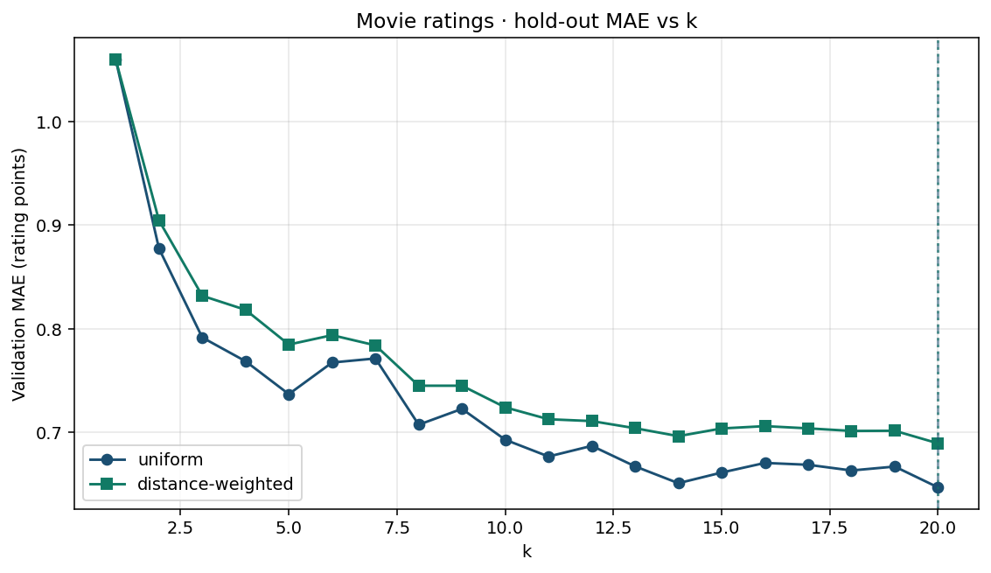
Validation MAE vs k (uniform vs distance-weighted). Companion: knn_regress_neighbors.png, knn_regress_weighted.png, knn_regress_simulation.png.

Key Takeaways
- Classifier votes; regressor averages. Weighted average lets the nearest ratings dominate.
- Normalize first. Unscaled budget quietly owns the neighbor list.
- Small k copies flukes; large k repeats the global mean. Pick k on hold-out MAE, not training fit.
- A query year beyond the training max is allowed to scale above 1 — do not clip.
- Cold start: a brand-new title (or user) with no nearby rows has nothing useful to average.

